**GRIEVANCES REDRESSAL PORTAL**

**PROJECT REPORT**

Submitted in partial fulfilment of the requirements for the award of the degree of

**BACHELOR OF TECHNOLOGY**

**(COMPUTER SCIENCE AND ENGINEERING)**

Undertaken at:

**DISTT. DEVELOPMENT AND PANCHAYAT OFFICE**

Submitted by:

**RUPALI BAWA**

Roll No.: 11801309

Regd. No.: 7141-18-529



**DEPARTMENT OF COMPUTER SCIENCE AND ENGINEERING**

**PUNJABI UNIVERSITY, PATIALA**

**MAY, 2021**

**DECLARATION**

I, RUPALI BAWA, hereby affirm that the project report titled “GRIEVANCES REDRESSAL PORTAL”, submitted to Punjabi University, Patiala in partial fulfilment of the requirements for the award of degree of B.Tech. (Computer Science and Engineering) is an authentic record of my own work and that to the best of my knowledge and belief, it contains no written material which has been accepted for the qualification of any other degree or diploma of a university or other institution of higher learning except where due acknowledge is made.

Name of student: Rupali Bawa

Roll no: 11801309

Regd. No.: 7141-18-529

**ACKNOWLEDGEMENT**

I am highly thankful to Dr. Raman Maini Sir, HOD Department of Computer Science and Engineering, Punjabi University, Patiala for providing me with this opportunity to carry out six weeks industrial training at Distt. Development and Panchayat Office, Patiala.

I would like to express my gratitude to other faculty members of Computer Science & Engineering Department of Punjabi University, Patiala, for providing academic input, guidance and encouragement throughout the training period.

Training is agglomeration of the theoretical and practical and technical concepts, which enhances our skills in the field of technology. This project is not a solo effort. I would like to add few words for the people who were a part of this project, people who gave never-ending support right from the beginning of the project. There is a long list of people who have directly or indirectly made this project possible. I express my sincere thanks to all of them.

I would first like to thank my project guide, S. Surinder Singh Dhillon, for his personal involvement and guidance, which has been extremely helpful in bringing about a successful fulfilment of the project. He has provided me all the necessary information and guidance which has proved to be of great help in the achievement of the goal. I would also like to thank all DDPO, Patiala staff for their valuable support and guidance. I am highly thankful to all the teachers of the department for their guidance and support.

Last but not the least, I express my indebtedness to all who have directly or indirectly contributed to the successful completion of my industrial training.

RUPALI BAWA

**ABSTRACT**

The well planned properly executed and evaluated training helps in the development and implementation of a project. It provides linkage between the student and the organization in order to develop the awareness of approach to problem solving based on broad understanding of process and mode of operation of an organization.

The project reports serve the purpose of elaborating the analysis and the implementation phases of the above-mentioned project. All the features included in the development and implementations are clearly explained to make the project easy to understand. A great care has been taken care of in this document to elicit the system development process in a clear and well-defined manner.

**TABLE OF CONTENTS**

|  |  |  |
| --- | --- | --- |
| **Sr. No.** | **Title** | **Page no.** |
| 1. | Declaration | 2 |
| 2. | Acknowledgement | 3 |
| 3. | Abstract | 4 |
| 4. | About the Organization | 6 |
| 5. | Tools and Technologies | 7-11 |
| 6. | About the Project | 12-14 |
| 7. | Screenshots of the project | 15-22 |
| 8. | References | 23 |

**ABOUT THE ORGANISATION**

**DISTT. DEVELOPMENT AND PANCHAYAT OFFICE, PATIALA**

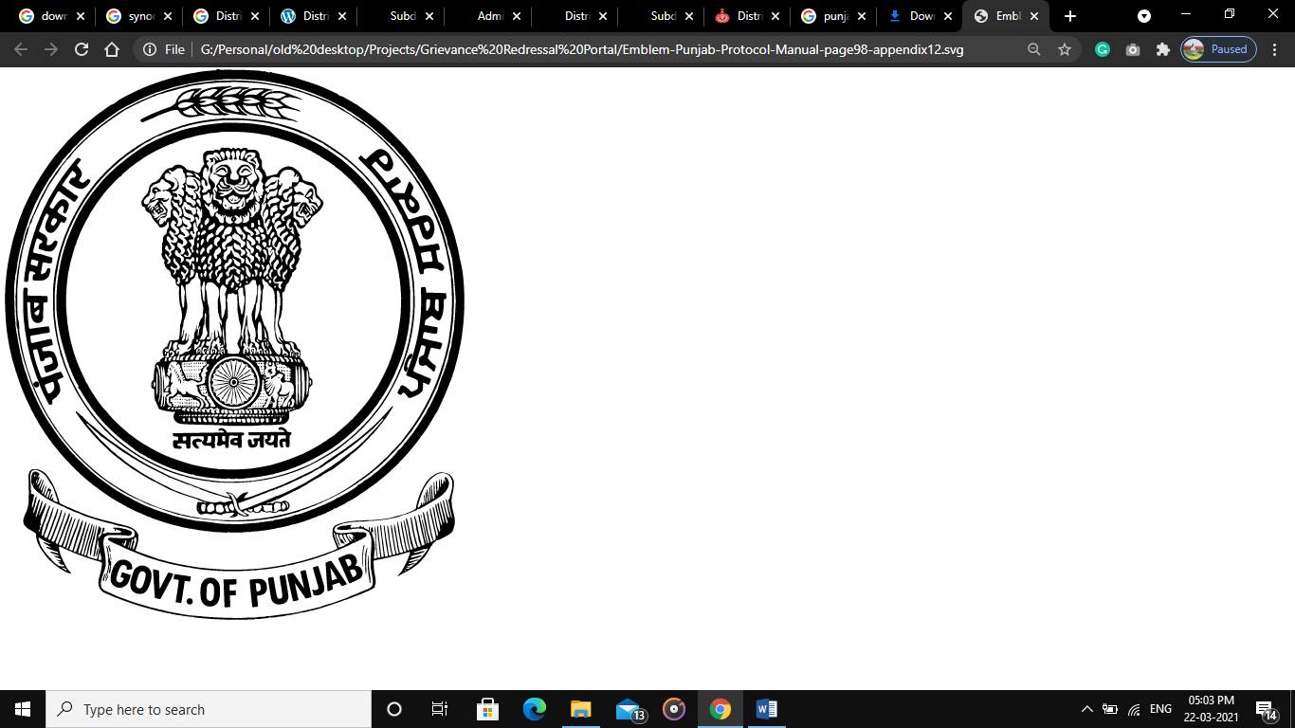District Development and Panchayat Office (DDPO) is one of the key department in the administration of district of Patiala. It is headed by DDPO Officer and falls under the administration of ADC (Development), Patiala. The role of department of Development becomes crucial whenever we discuss the state of development in any district. The DDPO, Patiala is a progressive and reformist department, with a transformative vision. The aim of the department is to not just achieve a developed city, but also all the villages falling under the jurisdiction.

Patiala district is one of the famous princely states of erstwhile Punjab. Forming the south-eastern part of the state, it lies between 29°49’ and 30°47’ north latitude, 75°58’ and 76°54’ east longitude.

# It is surrounded by the districts of Fatehgarh Sahib, Rupnagar and the Union Territory of Chandigarh in the north, Sangrur district in the west, Ambala and Kurukshetra districts of neighbouring state of Haryana in the east and Kaithal district of Haryana in the south. District Development and Panchayat Officer is the principal officer to help the Deputy Commissioner to carry on the community development and welfare programmes. He deals with the following subjects:-

1. Work relating to the development.
2. Five Year Plans, NITI Aayog plans and local development works.
3. Panchayat Samitis, Local Bodies and Panchayats.

Block development and Panchayat officers work at the block level subordinate of District Development and Panchayat Officer. District Patiala has 6 sub-divisions, 9 blocks, and 934 villages. Some of the most important functions like MNREGA scheme is the prime responsibility of the department. Other responsibilities include maintenance of the area, regulating, implementing and encouraging development works and initiatives. Public welfare are also one of prime responsibilities of the department. The department makes sure that new initiative and directives issued by the government are followed and implemented efficiently and rigorously.

**ABOUT THE TECHNOLOGY**

**JAVASCRIPT**: JavaScript (JS) is a scripting languages, primarily used on the Web. It is used to enhance HTML pages and is commonly found embedded in HTML code. JavaScript is an interpreted language. Thus, it doesn't need to be compiled. JavaScript renders web pages in an interactive and dynamic fashion. This allowing the pages to react to events, exhibit special effects, accept variable text, validate data, create cookies, detect a user’s browser, etc

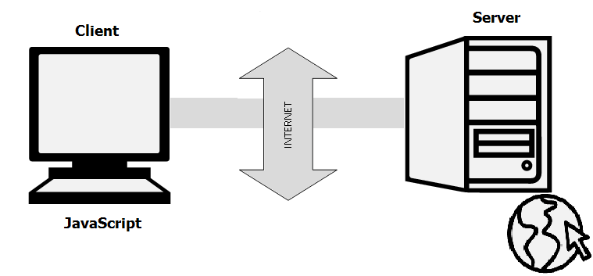

There are two ways to use JavaScript in an HTML file. The first one involves embedding all the JavaScript code in the HTML code, while the second method makes use of a separate JavaScript file that’s called from within a Script element, i.e., enclosed by Script tags. JavaScript files are identified by the .js extension. Although JavaScript is mostly used to interact with HTML objects, it can also be made to interact with other non-HTML objects such as browser plugins, CSS (Cascading Style Sheets) properties, the current date, or the browser itself.

**FEATURES:**

* JavaScript is an object-based scripting language.
* Giving the user more control over the browser.
* It Handling dates and time.
* It Detecting the user's browser and OS,
* It is light weighted.
* JavaScript is a scripting language and it is not java.
* JavaScript is interpreter based scripting language.
* JavaScript is object based language as it provides predefined objects.
* Most of the JavaScript control statements syntax is same as syntax of control statements in C language.

**HTML (HYPER TEXT MARKUP LANGUAGE): HTML** stands for Hyper Text Markup Language. It is used to design web pages using markup language. HTML is the combination of Hypertext and Markup language. Hypertext defines the link between the web pages. Markup language is used to define the text document within tag which defines the structure of web pages. This language is used to annotate (make notes for the computer) text so that a machine can understand it and manipulate text accordingly. Most of markup (e.g. HTML) languages are human readable. Language uses tags to define what manipulation has to be done on the text.  
HTML is a markup language which is used by the browser to manipulate text, images and other content to display it in required format. HTML was created by Tim Berners-Lee in 1991. The first ever version of HTML was HTML 1.0 but the first standard version was HTML 2.0 which was published in 1999.

* **Elements and Tag:** HTML uses predefined tags and elements which tells the browser about content display property. If a tag is not closed then browser applies that effect till end of page.
* **HTML page structure:** The Basic structure of HTML page is given below. It contain some elements like head, title, body, etc. These elements are used to build the blocks of web pages.

**CASCADING STYLE SHEETS (CSS): C**ascading **S**tyle **S**heets, fondly referred to as **CSS**, is a simply designed language intended to simplify the process of making web pages presentable. CSS allows you to apply styles to web pages. More importantly, CSS enables you to do this independent of the HTML that makes up each web page.  
CSS is easy to learn and understood but it provides powerful control over the presentation of an HTML document.

* **CSS saves time:**You can write CSS once and reuse same sheet in multiple HTML pages.
* **Easy Maintenance:**To make a global change simply change the style, and all elements in all the webpages will be updated automatically.
* **Search Engines:**CSS is considered as clean coding technique, which means search engines won’t have to struggle to “read” its content.
* **Superior styles to HTML:**CSS has a much wider array of attributes than HTML, so you can give a far better look to your HTML page in comparison to HTML attributes.
* **Offline Browsing:**CSS can store web applications locally with the help of offline catches. Using of this we can view offline websites.

**PHP (HYPERTEXT PREPROCESSOR): PHP** is a general-purpose scripting language especially suited to web development.It was originally created by Danish-Canadian programmer Rasmus Lerdorf in 1994.  The PHP reference implementation is now produced by The PHP Group. PHP originally stood for *Personal Home Page*, but it now stands for the recursive initialism *PHP: Hypertext Preprocessor*.

PHP code is usually processed on a web server by a PHP interpreter implemented as a module, a daemon or as a Common Gateway Interface (CGI) executable. On a web server, the result of the interpreted and executed PHP code – which may be any type of data, such as generated HTML or binary image data – would form the whole or part of an HTTP response. Various web template systems, web content management systems, and web frameworks exist which can be employed to orchestrate or facilitate the generation of that response. Additionally, PHP can be used for many programming tasks outside of the web context, such as standalone graphical applications and robotic drone control. PHP code can also be directly executed from the command line.

The PHP language evolved without a written formal specification or standard until 2014, with the original implementation acting as the *de facto* standard which other implementations aimed to follow. Since 2014, work has gone on to create a formal PHP specification.

**FEATURES:**

* PHP can generate dynamic page content
* PHP can create, open, read, write, delete, and close files on the server
* PHP can collect form data
* PHP can send and receive cookies
* PHP can add, delete, modify data in your database
* PHP can be used to control user-access
* PHP can encrypt data

### **STRUCTURED QUERY LANGUAGE (SQL):** SQL (Structured Query Language) is a computer language aimed to store, manipulate, and query data stored in relational databases. The first incarnation of SQL appeared in 1974, when a group in IBM developed the first prototype of a relational database.  According to ANSI (American National Standards Institute), it is the standard language for relational database management systems. SQL statements are used to perform tasks such as update data on a database, or retrieve data from a database.

* **Easy to use:** MySQL is easy to use. We have to get only the basic knowledge of SQL. We can build and interact with MySQL by using only a few simple SQL statements.
* **It is secure:** MySQL consists of a solid data security layer that protects sensitive data from intruders. Also, passwords are encrypted in MySQL.
* **Client/ Server Architecture:** MySQL follows the working of a client/server architecture. There is a database server (MySQL) and arbitrarily many clients (application programs), which communicate with the server; that is, they can query data, save changes, etc.
* **Free to download:** MySQL is free to use so that we can download it from MySQL official website without any cost.
* **It is scalable:** MySQL supports multi-threading that makes it easily scalable. It can handle almost any amount of data, up to as much as 50 million rows or more. The default file size limit is about 4 GB. However, we can increase this number to a theoretical limit of 8 TB of data.
* **Speed:** MySQL is considered one of the very fast database languages, backed by a large number of the benchmark test.
* **High Flexibility:** MySQL supports a large number of embedded applications, which makes MySQL very flexible.

**TOOLS**

1. **ATOM**: Atom is a free and open-source text and source code editor for macOS, Linux, and Microsoft Windows with support for plug-ins written in Node.js, and embedded Git Control, developed by GitHub. Atom is a desktop application built using web technologies. Most of the extending packages have free software licenses and are community-built and maintained. Atom is based on Electron (formerly known as Atom Shell), a framework that enables cross-platform desktop applications using Chromium and Node.js.  It is written in CoffeeScript and Less. Atom was released from beta, as version 1.0, on 25 June 2015. Its developers call it a "hackable text editor for the 21st Century".
2. **XAMPP:** XAMPP is a free and open-source cross-platform web server solution stack package developed by Apache Friends, consisting mainly of the Apache HTTP Server, MariaDB database, and interpreters for scripts written in the PHP and Perl programming languages. Since most actual web server deployments use the same components as XAMPP, it makes transitioning from a local test server to a live server possible. XAMPP's ease of deployment means a WAMP or LAMP stack can be installed quickly and simply on an operating system by a developer, with the advantage that common add-in applications such as WordPress and Joomla! can also be installed with similar ease using Bitnami.

**ABOUT THE PROJECT**

**GRIEVANCES REDRESSAL PORTAL**

**OBJECTIVES:**

The proposed system is an online complaint management system for submitting complaints online by using the said portal, a user or a subject can upload/post his complaint from anywhere by using this website on his phone or PC, online. GRP is an easy and secure way as compared to the previous methods used by the department like ‘complain box’, which was difficult to manage and accountability was very low.

Due to an online compliant box, manual effort and wastage of paper will also decrease. Residents of Patiala district can submit their complaint very quickly and anonymously. User can check the current status of their complaints and can view that what kind of action has been taken on their complaint.

The proposed system will show the current status of the complaint that whether it is ‘in processing’ or ‘closed’. It is based on centralize management, i.e. only the Admin can address the complaint. Admin has the authority to remove a complaint that has been addressed or any unnecessary or false complaints. Centralized management for checking current status of complaint and updating status of complaints. Admin can generate a report of this system in between selected date of his own choice.

The system would introduce some much needed transparency and accountability in the functioning of government departments. It will not only encourage honest and efficient working conditions, but is also set to improve the overall public welfare, which is also the aim of the department.

**FEATURES:**

* More accountability and transparency
* Effective support and redressal mechanism
* Reduce amount of paperwork.
* Reduced operational time.
* Increased accuracy and reliability.
* Reducing human efforts.
* Easy maintenance of Data.
* Data security.
* Timely management of redressal mechanism
* Improved functioning of the department

**FUTURE SCOPE:**

As ambitious as this project already is, there can be several improvements as well as additional features that can be introduced in the project as well as in its scope of implementation. It is highly recommended that the project be not limited to only a single department of the district administration, but be implemented for all the administrative purposes. System is built with scalability in mind, and hence can be easily extended to encompass more departments.

Further, the project can be made more mobile-friendly. Although, it was a target for the current version, but due to time constraints, it did not come to fruition, but can also be incorporated easily. Moreover, the UI/UX design can be improved further with more animated widgets and screens. With these improvements, the system can be even more easy to use and beneficial to the users.

**FEASIBILTY ANALYSIS:**

Feasibility study defines all the requirements to performance characteristics of system. For system to be feasible, the design needs to undertake various factors or performance requirements by which the system will be operated.

A feasibility study is short, focused study which aims at selecting the best system that meets performance requirements. Information is gathered regarding the general requirements of the proposed system.

If feasibility study is to serve as the decision document, it answers a number of questions.

Like:

* Is it beneficial?
* Does it save time and money?
* Can it be integrated with other systems already in place?

Planning resources is a very vast concept and we are beginners, thus including each and every aspects of web, Integrate and automate them in every respect was not feasible for us. Hence we perform feasibility study to make our project compatible for present environment. The concept of HR Management is newer. The project is built with the help of **Python** which is reliable and an efficient platform to work upon.

**TECHNICAL FEASIBILITY:**

Technical feasibility takes of the all the issues concerned with the design and the development part of the project. It concerns itself with the software, hardware and the platform related issues. The following are the technical specifications for our project.

The project would require a lot of space for storage of static as well as dynamic content. As the number of project available increases the space required for storing them increases.

**ECONOMIC FEASIBILITY:**

* It provides an efficient and reliable platform to work upon.
* It saves time and is thus a faster means of company and individual profile details.
* It is less tough than the manual management of all the data that is shown in the project

**HARDWARE REQUIREMENTS:**

* **Processor**: 32-bit, 4-core, 1.5 GHz minimum per core
* **RAM**: 256 MB (minimum)
* **Hard** **disk**: 1 GB
* **Peripherals**: Mouse and Keyboard
* **Internet Connectivity**: Required

**SOFTWARE REQUIREMENTS:**

* **Operating System:** Window XP and above
* **Front end**: HTML, CSS, JavaScript
* **Back end**: XAMPP Server

**SCREENSHOTS**

**INDEX PAGE:** It is first page of the system that the user interacts with. It has a brief description of the system, department and acknowledges the contributors. Below it is pictorial representation of how the entire system works. The user can study the flowchart to understand the working of the system and how to use it effectively.

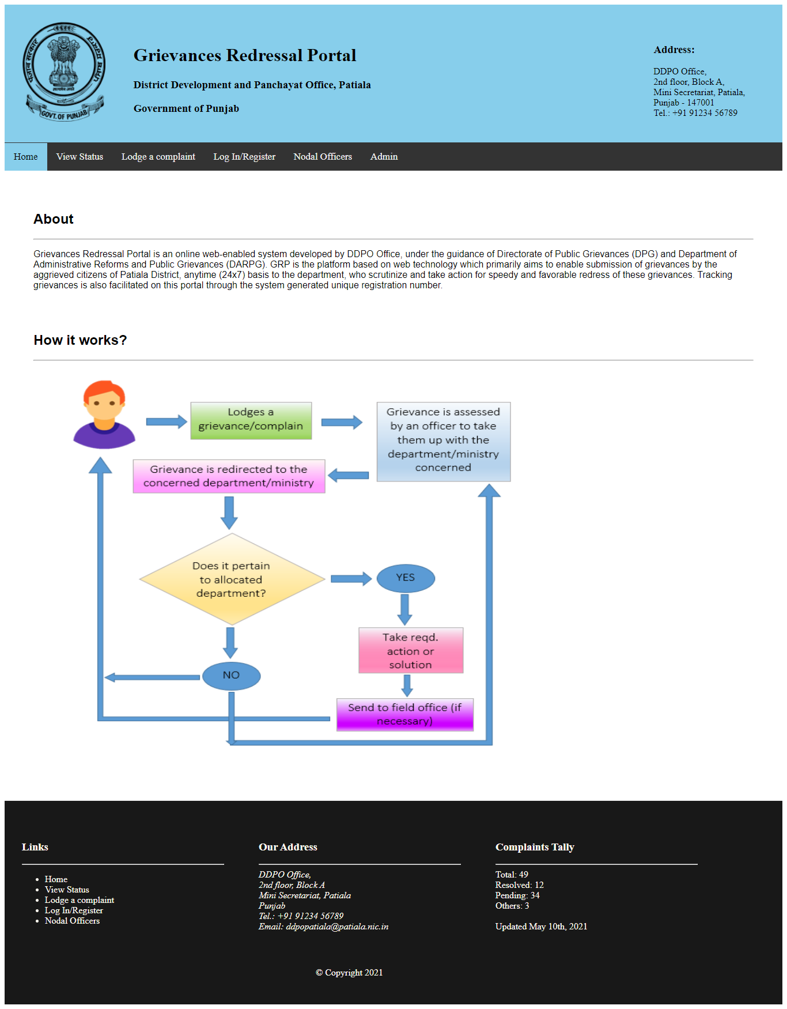

Screenshot 1

**VIEW COMPLAINTS:** This page allows for the general public to view complains that have posted either by them or others. The page maintains anonymity of the complainants and they’re identities are not revealed. Along with the number of complains, page also lists whether they are pending or resolved.

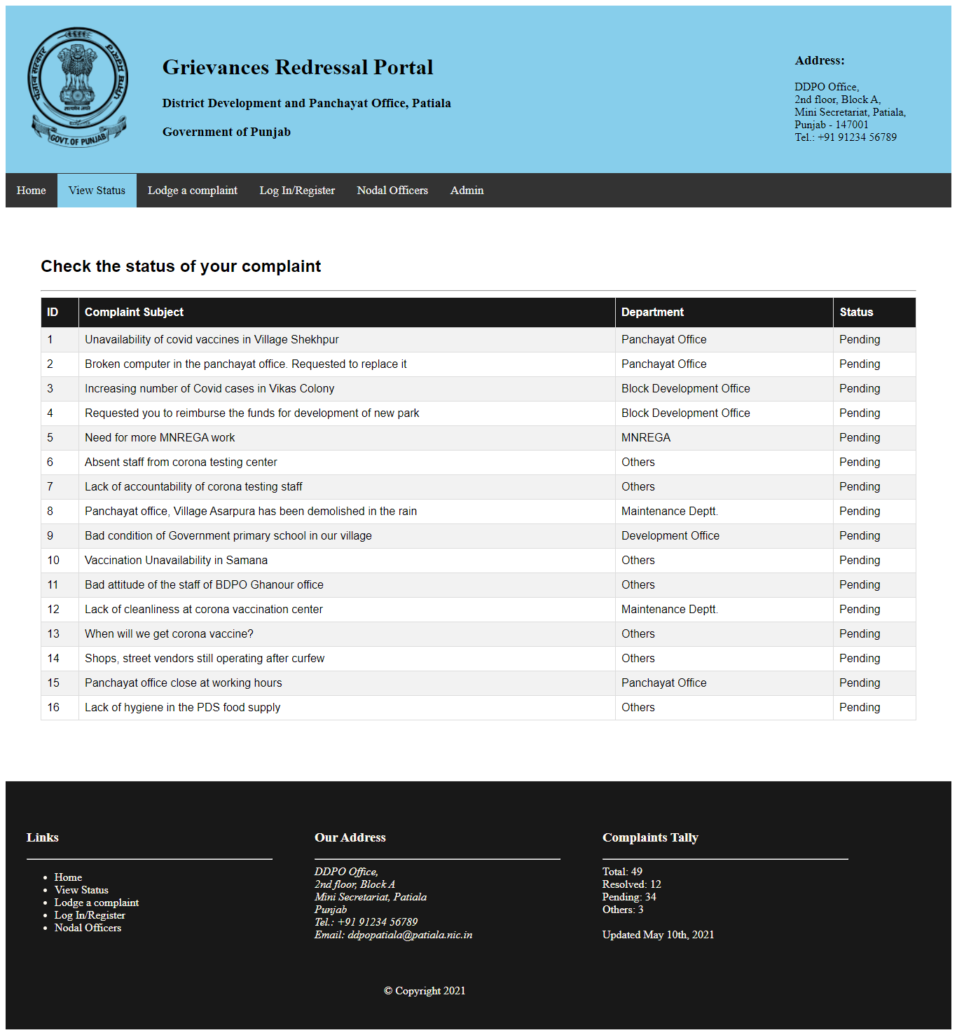

Screenshot 2

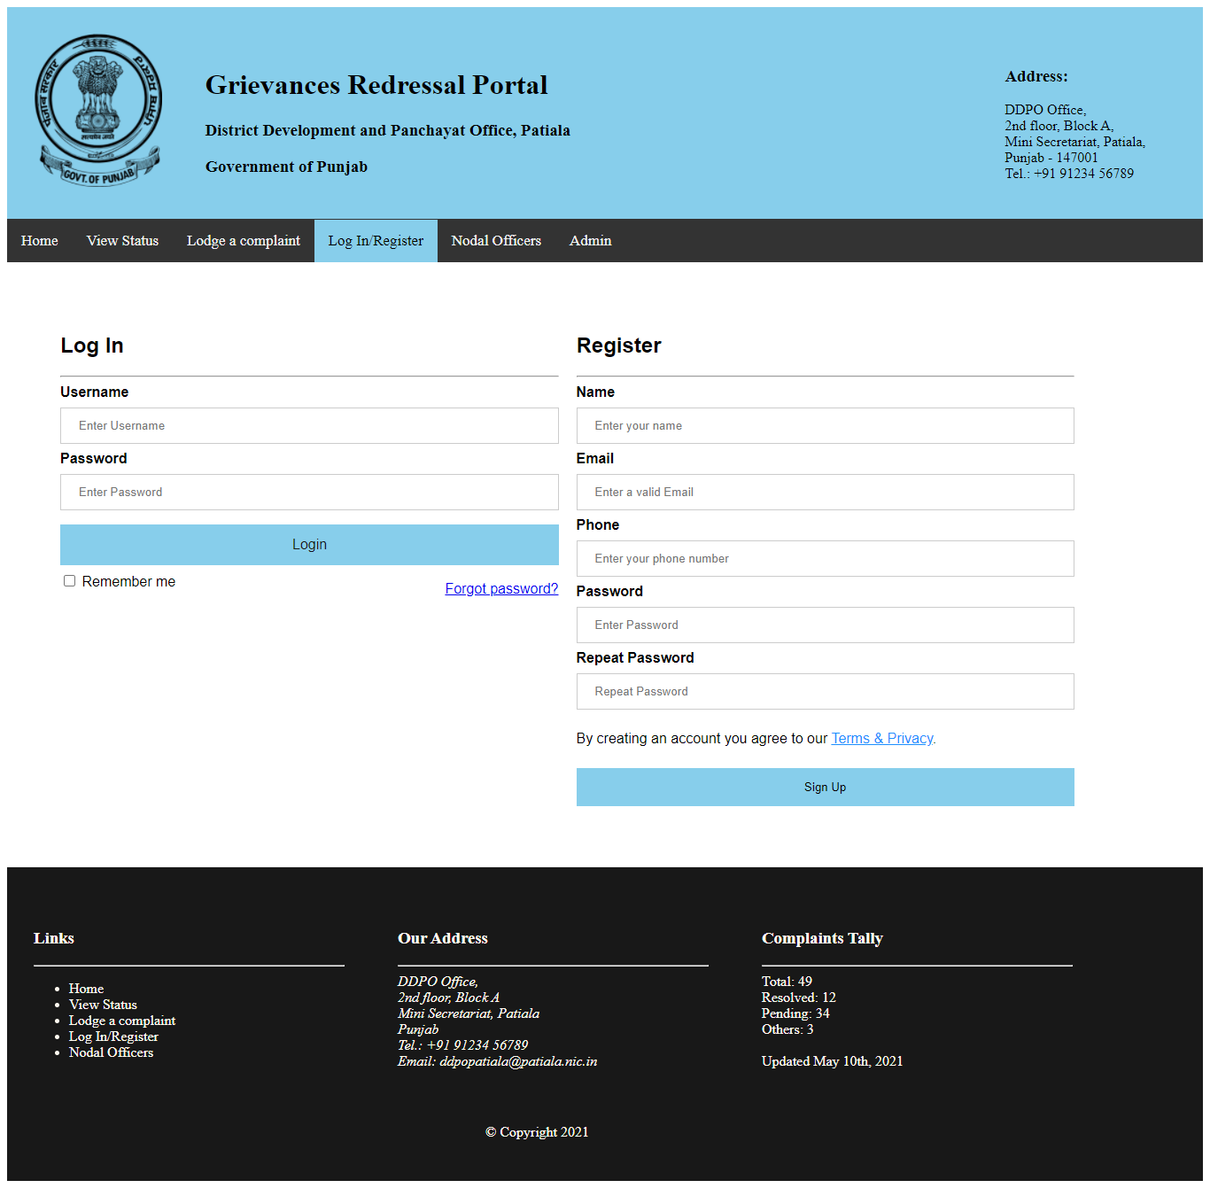**LOG-IN/REGISTER PAGE:** This page allows users to sign up or log in into their existing accounts. Signing up is necessary to register, as users need an ID to lodge a complaint.

Screenshot

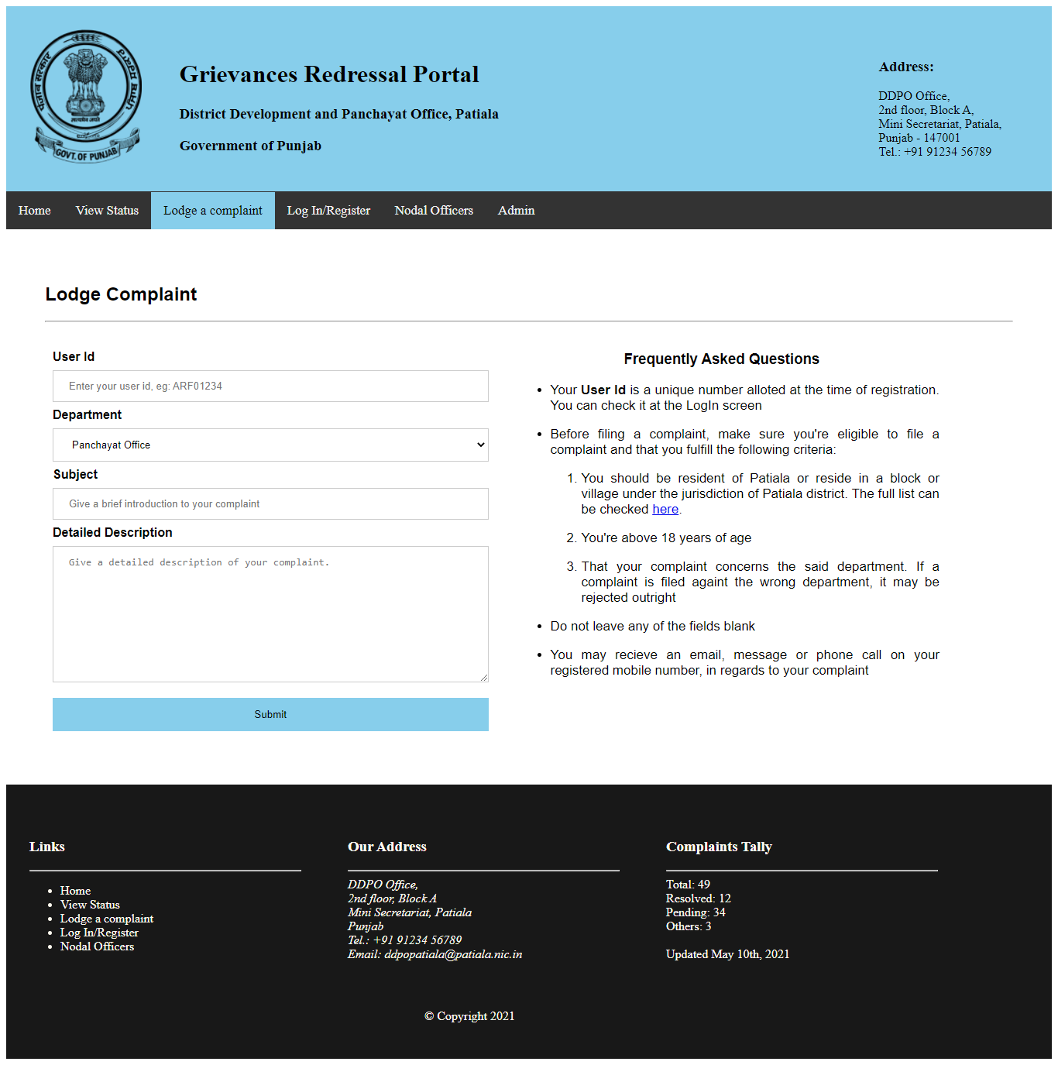**LODGE A COMPLAINT:** This page allows the users to file a complaint/grievance. The process has been kept very simple intentionally to make it easier for users to lodge the complaint without too many hurdles. On the right side are suggestions that the user may need while lodging his/her grievance.

Screenshot 4

**LIST OF NODAL OFFICERS:** In order to maintain complete transparency and on the account of accountability, this list has been incorporated here.

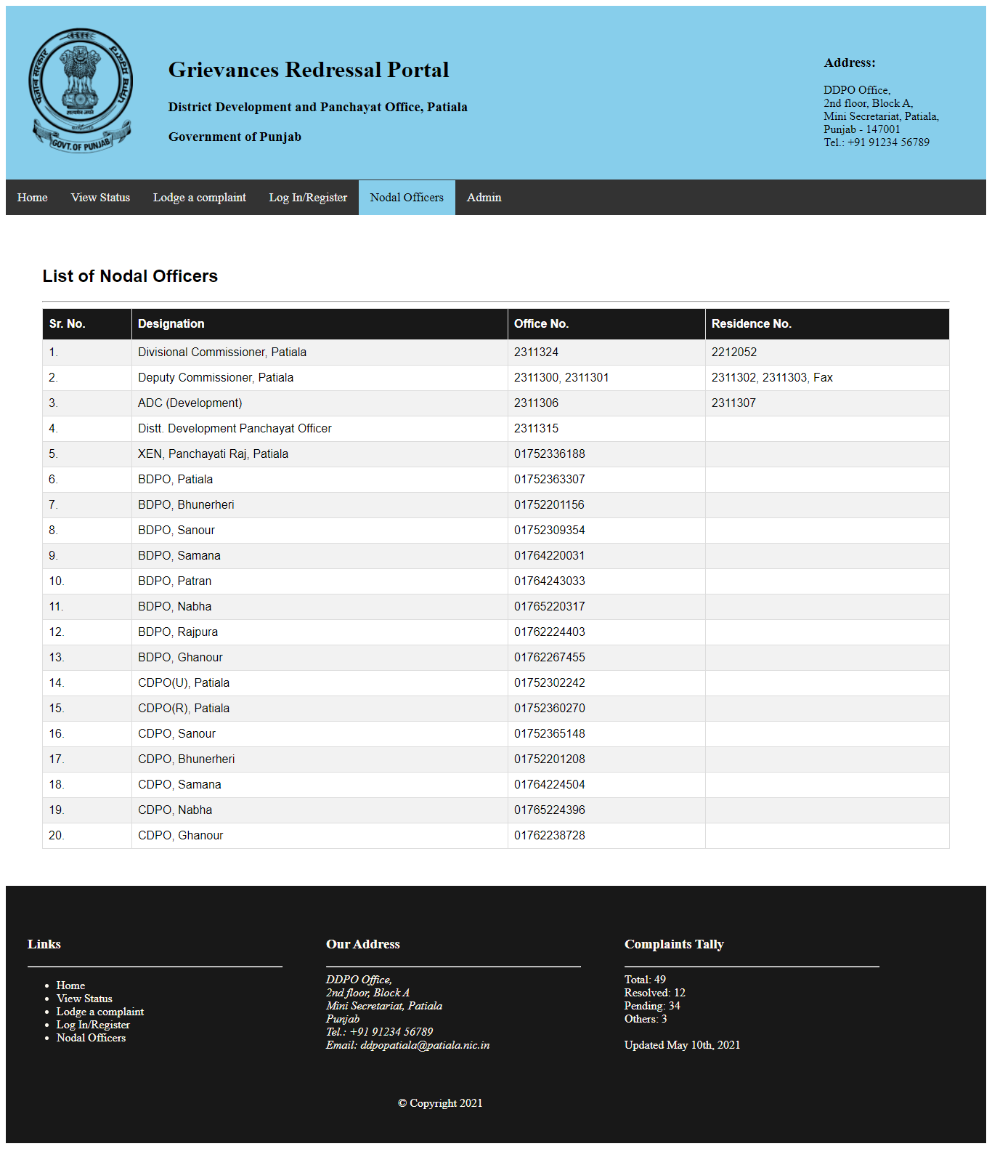

Screenshot 5

**ADMIN LOG-IN:** The page allows for the administrator to log in.

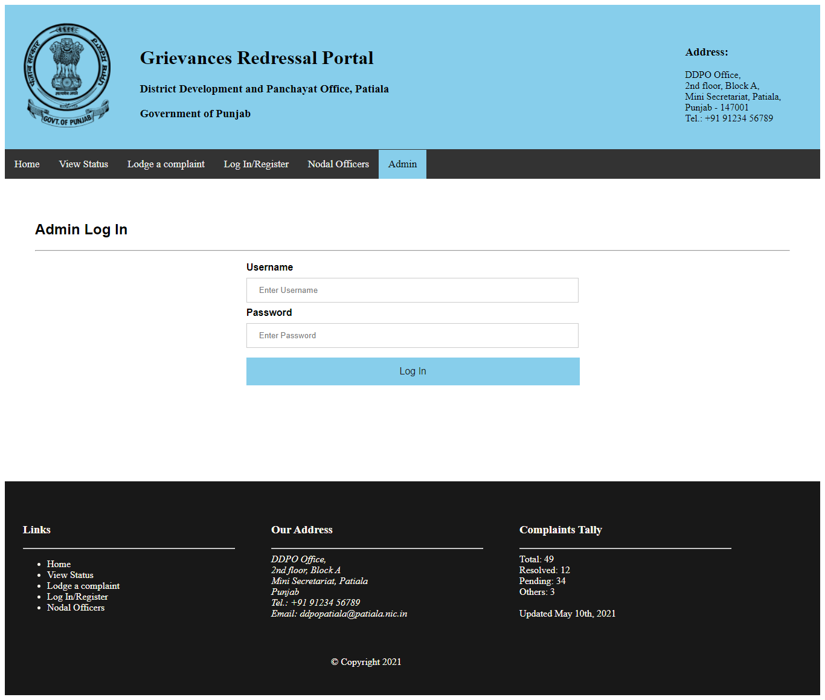

Screenshot 6

**ADMIN SCREEN:** Admin can view the detailed complaints, in order to address them or to assign them to correct department.

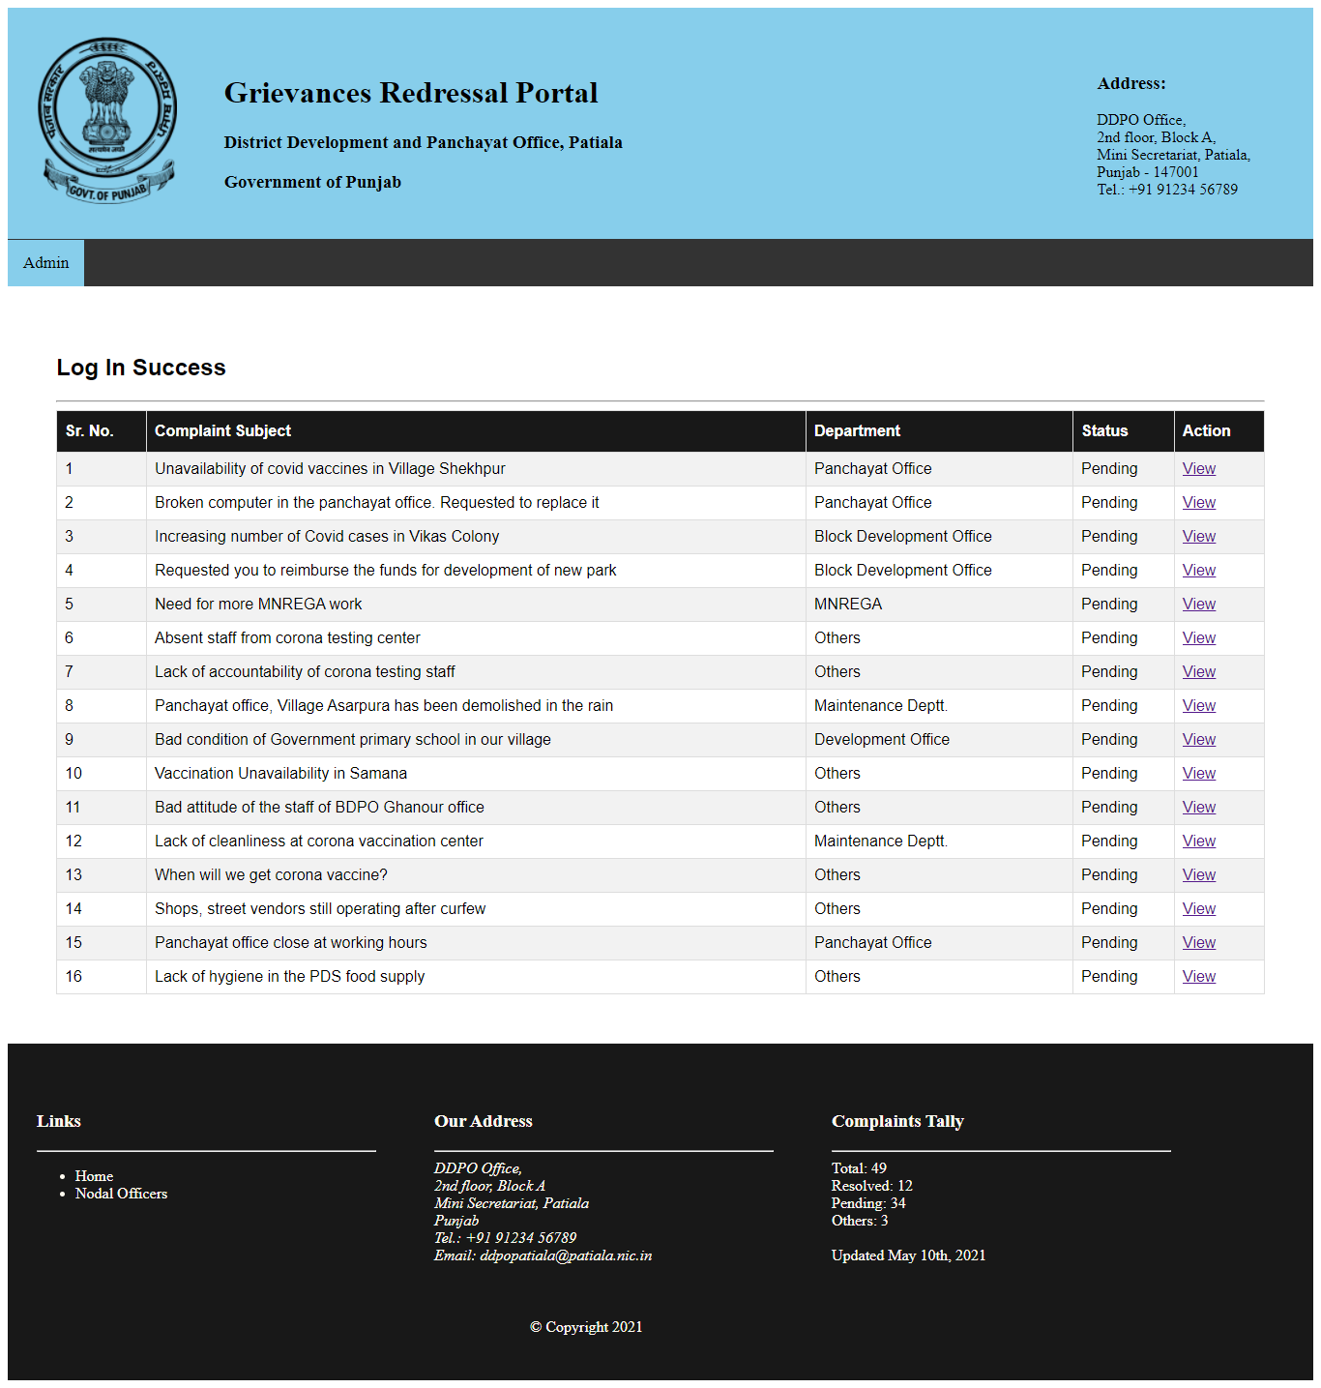

Screenshot 7

By clicking on “view”, admin can view the contact number of the applicant.

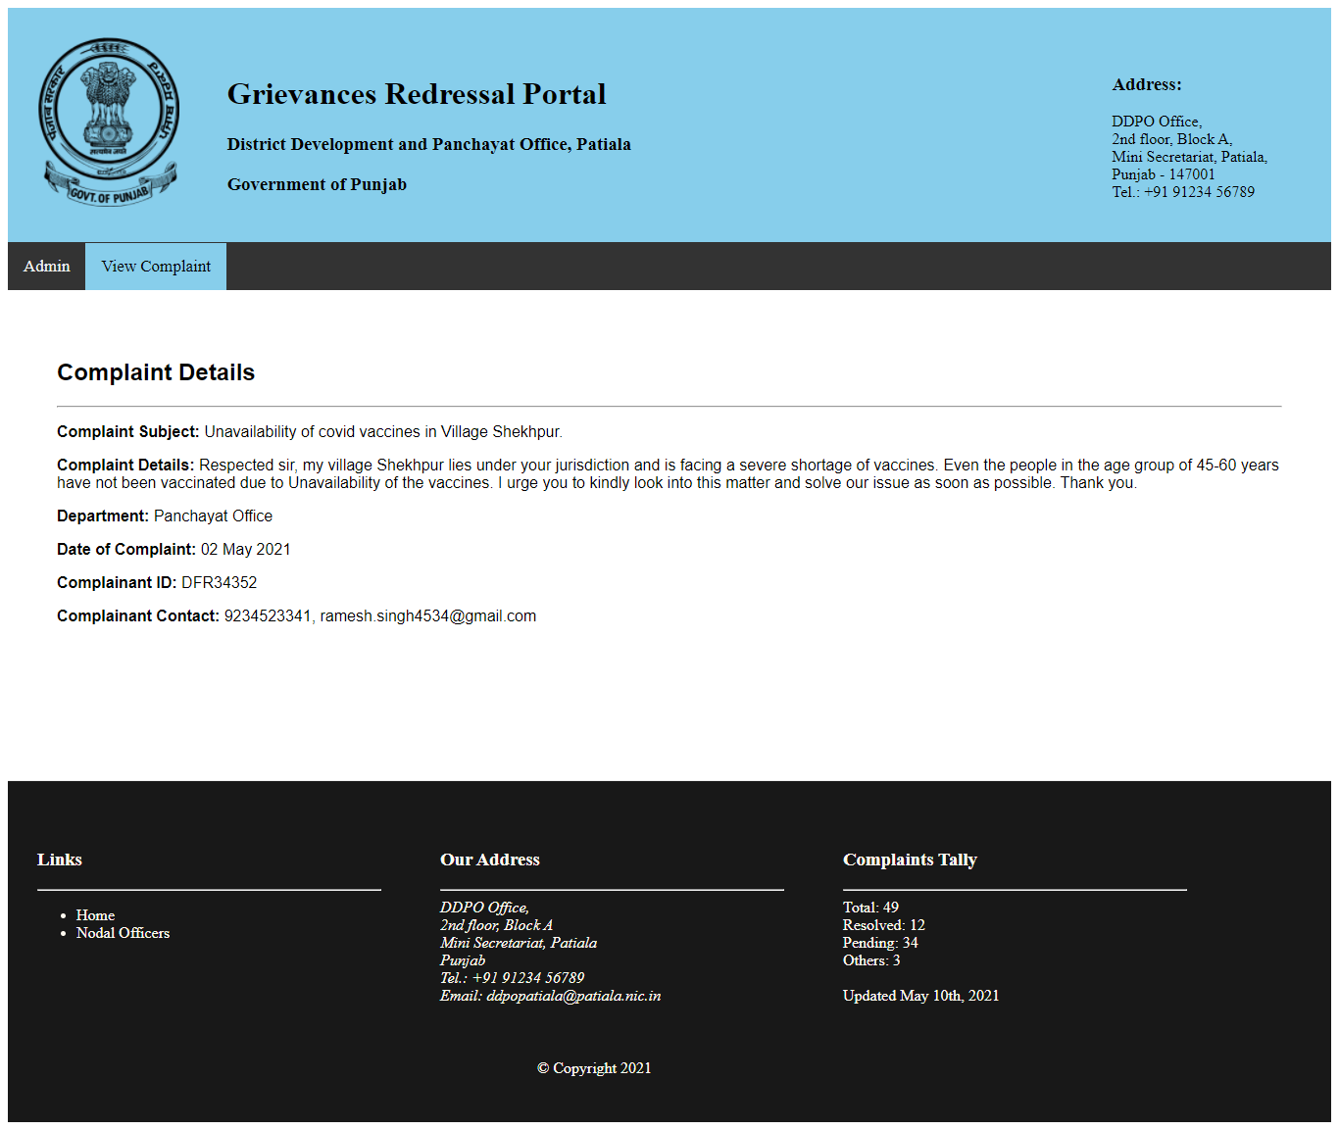

Screenshot 8

**REFERENCES**

* Mrs. Preeti Yadav, ADC (Development)
* S. Surinder Singh Dhillon, DDPO Officer.
* District Patiala, Patiala.nic.in/
* Google, www.google.co.in
* TechNet – Microsoft Pvt. Ltd., technet.microsoft.com
* CodeAcademy, learntocodewith.me
* W3 Schools, w3schools.com
* XAMPP, from Wikipedia, the free encyclopaedia
* Atom, from Wikipedia, the free encyclopaedia
* PHP, php.net
* StackOverflow, stackoverflow.com/
* GitHub, github.com/